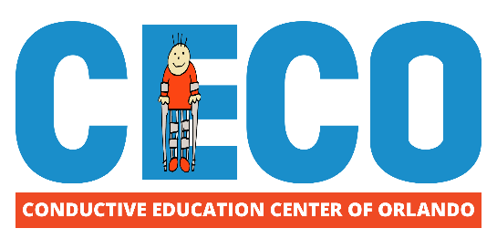
Contact Information:
Sophie Granville
Director of Development
The Conductive Education Center of Orlando (CECO)
407-671-4687
sgranville@ceco.org

For Immediate Release:

Conductive Education Center of Orlando (CECO) Ushers in New Era with Promotion of New Executive Director

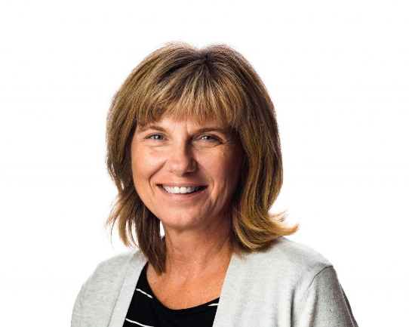
The Conductive Education Center of Orlando (2021)- An imaginative nonprofit center for children and adults with neurological motor disabilities, the Conductive Education Center of Orlando (CECO), is proud to be announce the promotion of Krisztina Weiszhaupt to Executive Director of the organization.

“The quality and success of our programs and center are recognized throughout the world. I am confident you will find, under [Weiszhaupt’s] ongoing leadership, that CECO will continue to grow and flourish as we accomplish new things together in her more than capable hands,” says Joe Raymond, CECO Parent, Founder, and Chairman of the Board.

CECO, now in its 21st year of operation, provides Conductive Education based programming to hundreds of families with children and adults with neurological motor disabilities, like Cerebral palsy and spina bifida. Through eight diverse programs, including a new Virtual Conductive Education program, CECO continues to expand to serve more participants of all ages with each passing year.

If you’d like to learn more about how you can support CECO’s impact here in our community, contact CECO’s Director of Development, Sophie Granville, at sgranville@ceco.org. Visit us online at www.ceco.org or visit our Facebook page for more information.

